**Full Stack Java Developer**

Capstone Project Problem Statement



**mAadhar Application**

**Problem statement:**

Develop an application to automate the process of applying for an Aadhar Card by making it smoother for Indian citizens.

**Scenario:**

**Varniraj Service PVT. LTD** is closely working with “The Government of India” to help them get a solution for processing applications for Aadhaar Card. Application is intended to register citizens and let them display ID to process their Aadhar Card application.

**Expected Deliverables:**

**Features of the application:**

* Registration
* Login
* Apply for a new Aadhar Card
* Place a request for updating Aadhar details
* Apply for a duplicate Aadhar Card
* Admin: Approve Aadhar Application and issue new Aadhar number
* Apply to close Aadhaar card (due to death)

**Recommended technologies:**

* **Database:** MySQL
* **Backend:** Java Programming (Spring Boot, JPA, Hibernate)
* **Frontend:** Angular, Bootstrap, and HTML/CSS
* **Automation and testing technologies:** Selenium and TestNG
* **DevOps tools/technologies:** Git, GitHub, Jenkins, and Docker
* **Optional implementation:**Kubernetes, AWS

**Project development guidelines:**

* The project will be delivered within four sprints with every sprint delivering a Minimal Viable Product.
* It is mandatory to perform proper sprint planning with user stories to develop all project components.
* The learner should use the above-mentioned technologies for different layers of the project.
* The web application should be responsive and should fetch or send data dynamically without hard-coded values.
* The learner must maintain the version of the application over GitHub, and every new change should be sent to the repository.
* The learner must implement a CI/CD pipeline using Jenkins.
* The learner should also deploy and host the application on an AWS EC2 instance.
* The learner should also implement automation testing before the application enters the CI/CD pipeline.
* The learner should use Git branching to perform basic automation testing of the application in it separately.
* The learner should make a rich frontend of the application, which is user-friendly and easy for the user to navigate through the application.
* There will be two portals in the application, the admin and user portal.

**Admin Portal:**

The admin portal deals with all the backend data generation. The admin user should be able to:

* Login through admin credentials
* Approve new Aadhaar Card request
* Verify request for duplicate Aadhaar
* Display all issued Aadhaar Card
* Delete Aadhaar card details for dead citizen

**User Portal:**

It deals with user activities. The end-user should be able to:

* Sign in to apply for a new Aadhar Card
* Login to see the Aadhar number assigned by the admin
* Update address, phone number, and date of birth of Aadhaar Card
* Request duplicate Aadhaar Card

**Frontend Validation:**

* For admin: The password should have at least: One Uppercase, one lowercase, one special character (@,#,&….), and one number.
* For citizens: The password should consist of only digits.

**Backend Validation:**

* Mobile number validation should be applied.
* Password length should not be less than 6 characters.
* For citizens: The home page would authenticate only if the mobile number provided in Aadhaar is matching with the password.

**Sample Input data for Backend REST API:**

* To register new citizens:

HTTP Method: POST

URL: http://localhost:6789/AadharApp/citizens

Request Body:

{

"name": "Uttam Patel",

"dob": "2011-08-23",

"address": "2/5 Heerabagh Flats",

"emailId": "uttampatel0811@gmail.com",

"mobileNo": "7976694711",

"gender": "Male"

}

* Apply for Aadhar Card using an existing citizen ID:

HTTP Method: POST

URL: http://localhost:6789/AadharApp/issueAadhar

RequestBody:

{

"citizenId": 1002,

"passportId": null,

"issueDate": "2020-04-25"

}

**Sample login page:**

**Sample user portal:**

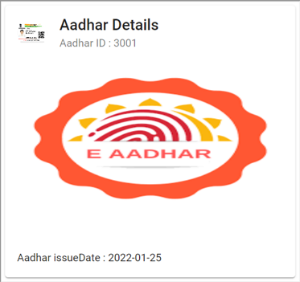

**Sample admin portal:**

